PS Lab 07

IT24102097

1. 
2. 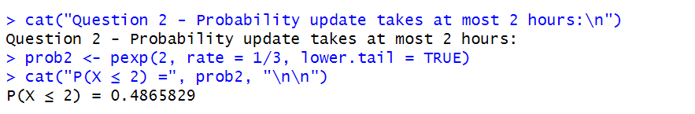
3. Part I : 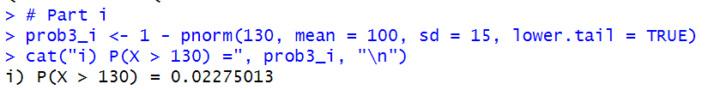

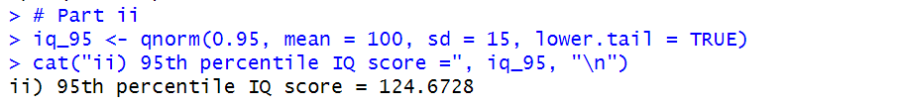 Part ii :